LOGBOOK  
1/October/2018

Team 1 : (Game Title Here)

Artist :

* Membuat sketsa kasar dan test art untuk game yang sudah direncanakan sesuai dengan rancangan game

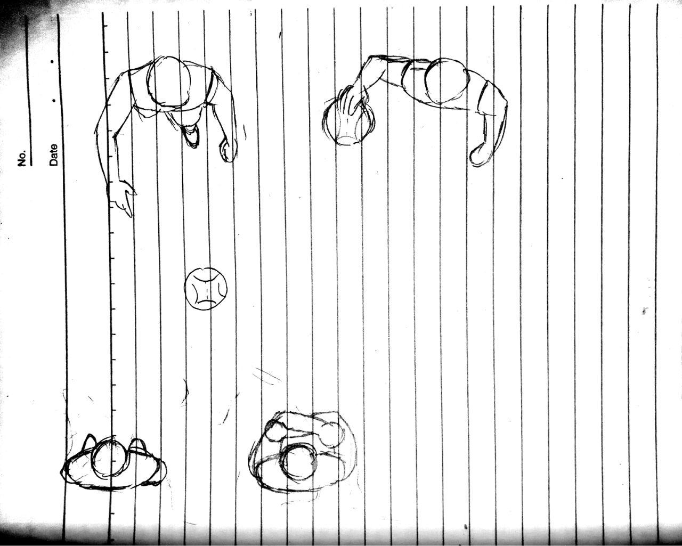

* Game dibuat dengan model top view



* Teman-teman Suanton (*enemy*) yang suka membully. Dibuat dengan tampak wajah jahat

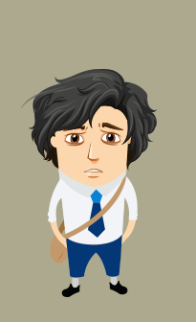

* Char utama, Suanton. Dibuat dengan wajah sedih dan lusuh karena penampilannya yang membuatnya di Bully.
* Brainstorming untuk art selanjutnya.

Programmer :

Movement Player

PlayerMovement.cs

using System.Collections;

using System.Collections.Generic;

using UnityEngine;

public class PlayerMovement : MonoBehaviour {

// Use this for initialization

void Start () {

}

// Update is called once per frame

void Update () {

Debug.Log("X: " + transform.position.x);

// Keyboard Input

if (Input.GetKey("d"))

transform.Translate(0.1f, 0, 0);

if (Input.GetKey("a"))

transform.Translate(-0.1f, 0, 0);

// End of Keyboard Input

// Accelerometer Input

transform.Translate(Input.acceleration.x, 0, 0);

// End of Accelerometer Input

// Border of Movement

if (transform.position.x >= Screen.width / 100)

transform.position = new Vector2(Screen.width / 100 - 0.1f, transform.position.y);

if (transform.position.x <= -Screen.width / 100)

transform.position = new Vector2(-Screen.width / 100 + 0.1f, transform.position.y);

// End of Border of Movement

}

}

Game Design :

- Game Stage Design  
Files in : ../Game Design Document/Game Stage Design – Chapter 1.docx

To do :

Chapter 1 Stages progressive story.

Adjusting game mechanics.